WELCOME TO
MANGAWHAI

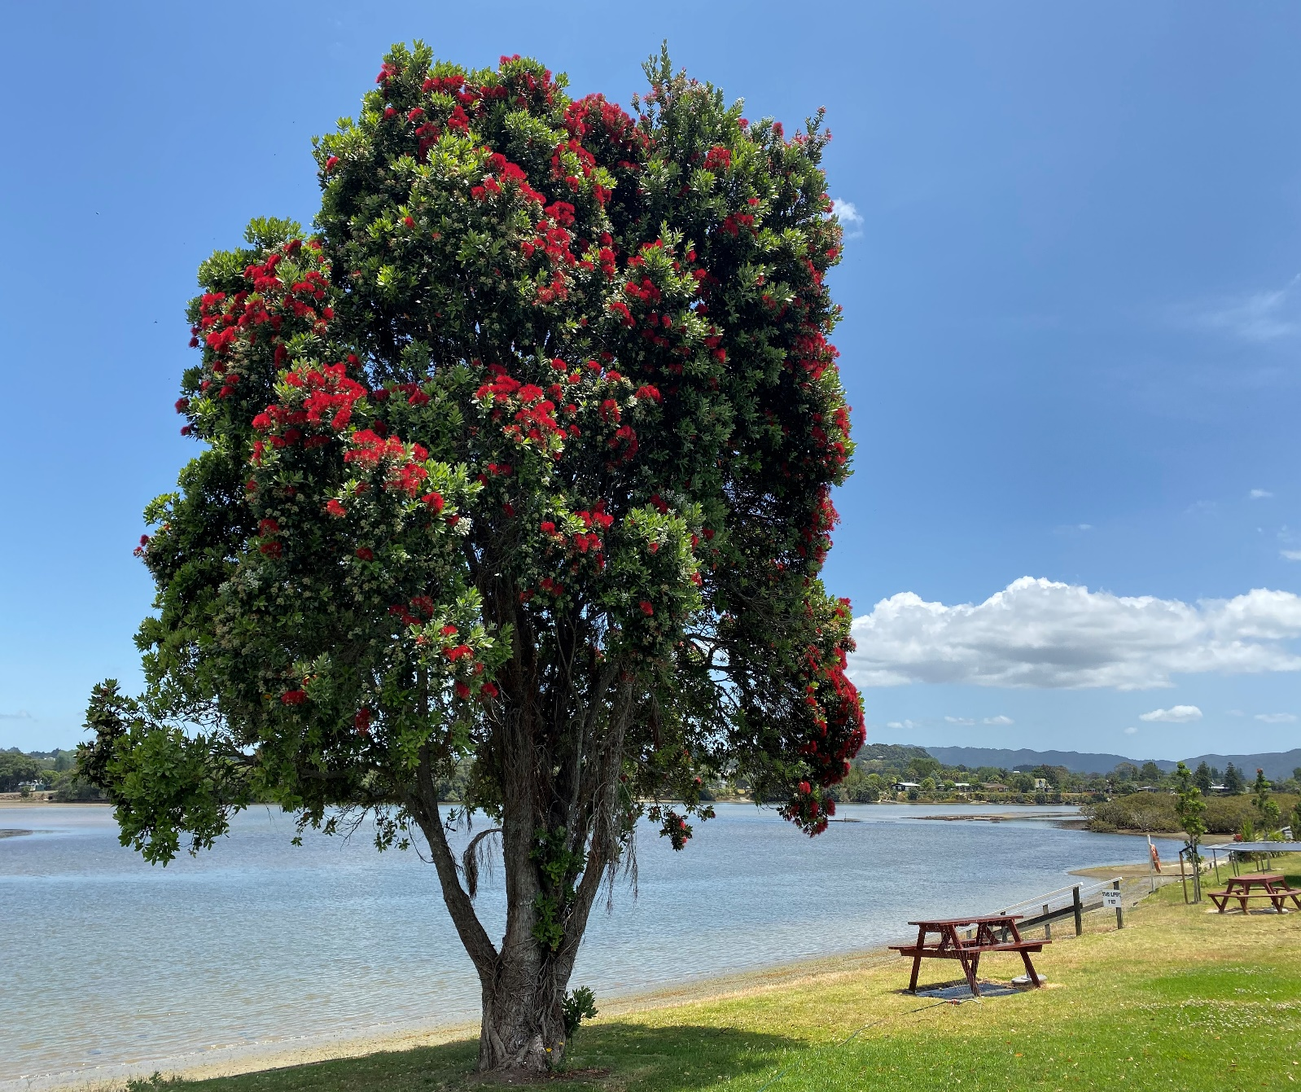
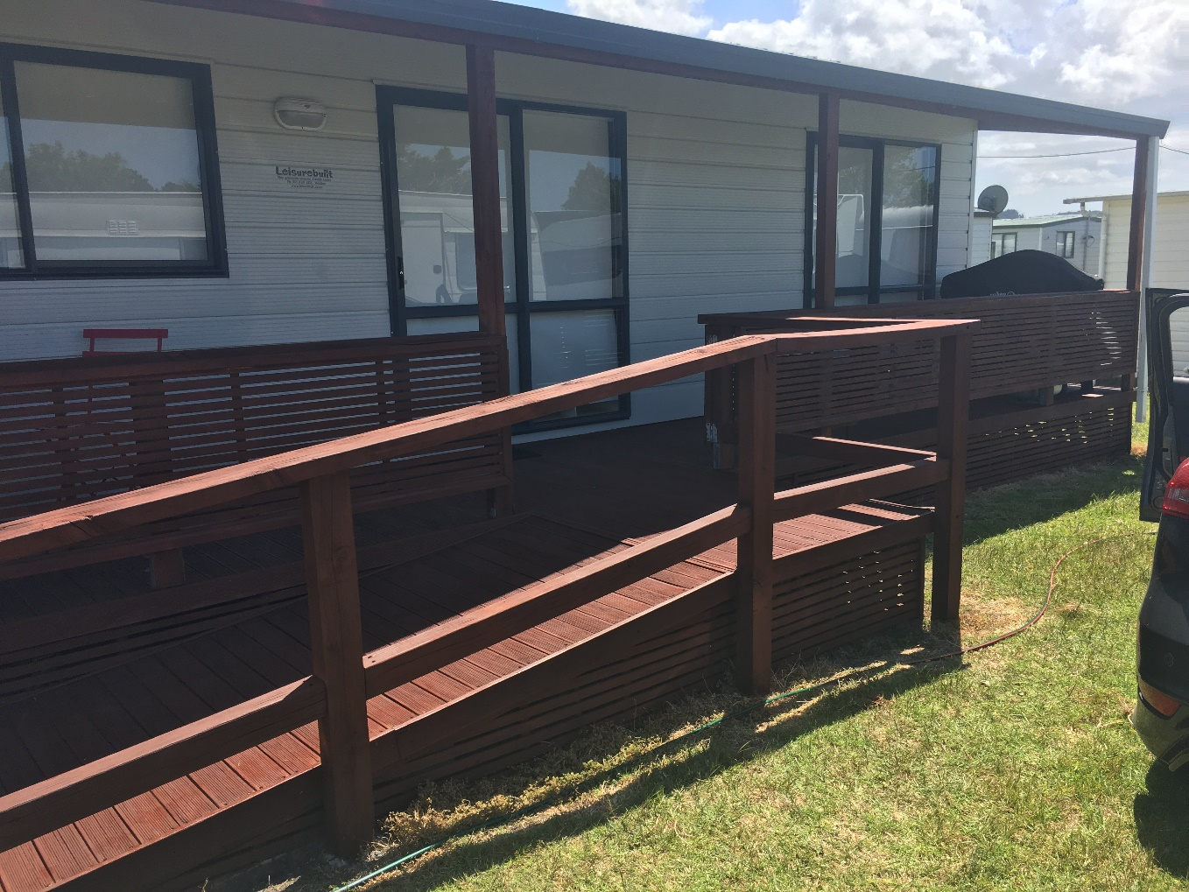
The Foundation is committed to offering respite care to patient members/families affected by the pressures of on-going health issues. Red Beach is on of the Respite homes available for use by our Patient members; this facility is very precious to us and we are grateful to all the trusts, businesses and individuals that have helped us to fundraise to establish and maintain this for our members.

The Mangawhai respite home is the place to go for much needed time out for both children and their families.

Our Mangawhai house sleeps up to 6 People and is fully self-contained with everything a family needs all you need to bring is yourselves!

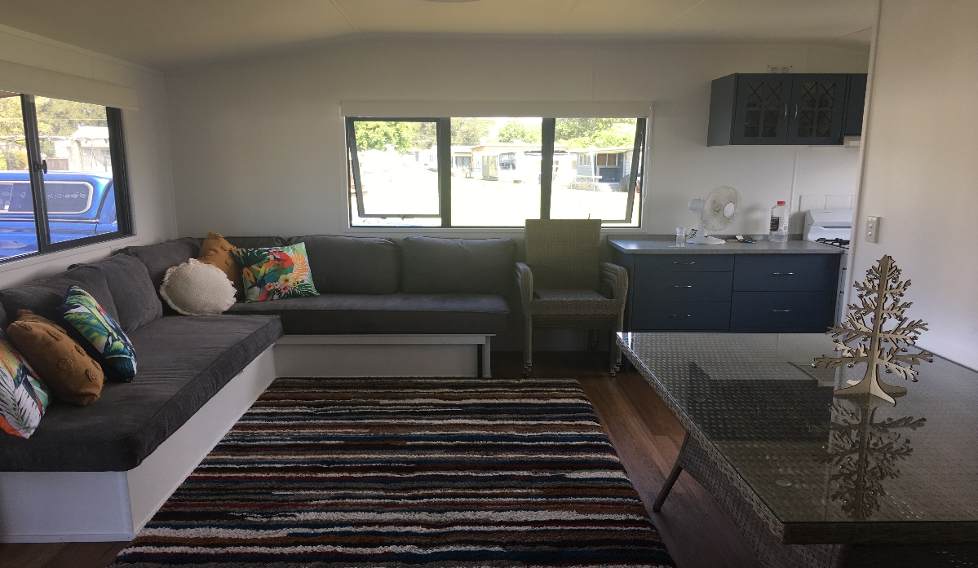

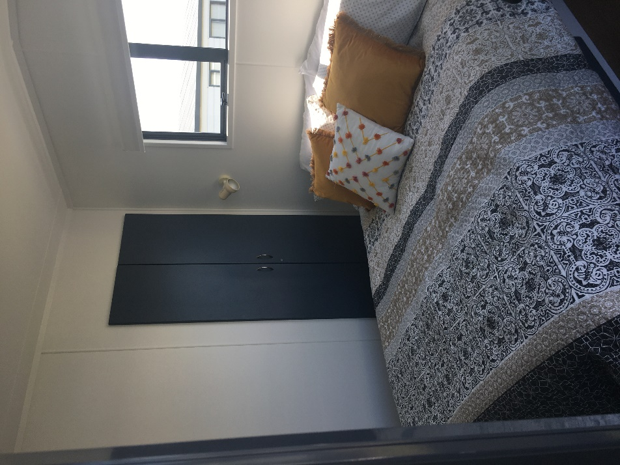
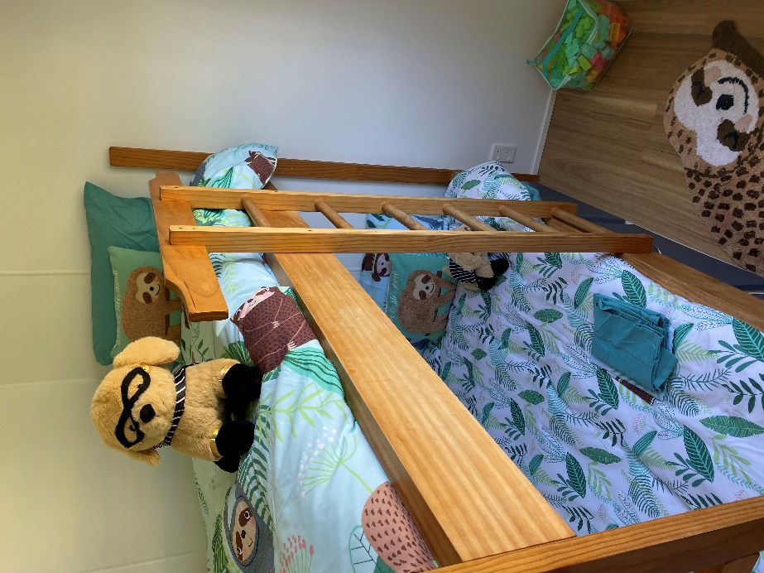

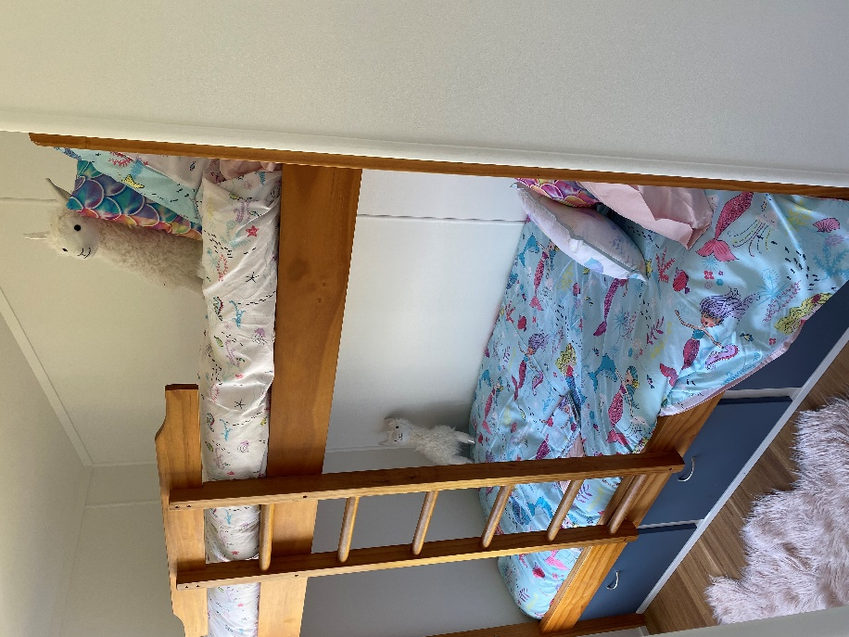

Booking your Holiday
We ask that you complete a booking Request form at least one month in advance of a planned holiday to allow time to process your request
The cost for hiring this fantastic home is as follows
$50 – Deposit (includes first night’s accommodation)
$20 – Per night (after initial $50 deposit has been paid)
Bookings can be made a maximum of 6 months in advance. One “Summer” holiday booking per family/per holiday home in peak summer periods (Dec-Mar) however there is no limit on off-peak/winter bookings. All homes are well insulated and suitable for winter use.

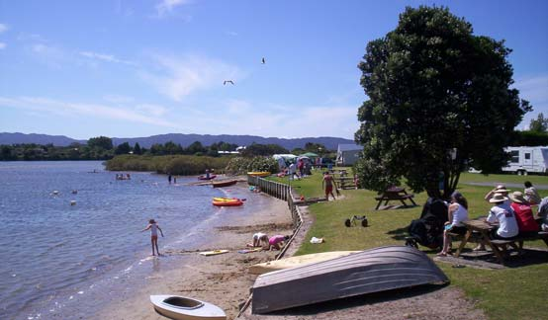

Terms and Conditions
All bookings are subject to availability
No Animals (Foundation policy regardless of campsite rules)
No Smoking
No Illegal substances
No Wilful damage of property
In the case of genuine medical treatment involving syringe use, we require further details in order to ensure satisfactory safety and disposal arrangements are in place.
Once your booking is accepted full payment is required a minimum of 2 weeks in advance of occupancy. A portion of the booking donation is non – refundable to cover admin expenses.
Where bookings are cancelled up to 2 weeks prior to the occupancy date, the payment may be deferred to an agreed alternative date falling within 6 months. Where bookings are cancelled less than the 2-week lead time or where a suitable booking is not agreed within the following 6 months a partial refund will be made, with the initial $50 booking fee being deducted to offset admin booking expenses.
The only thing we ask is that you use the vacuum cleaner stored in the main bedroom wardrobe and vacuum the floors, ensure the BBQ is clean and dishes are done before leaving. A $50 cleaning fee will be charged for failure to do so.

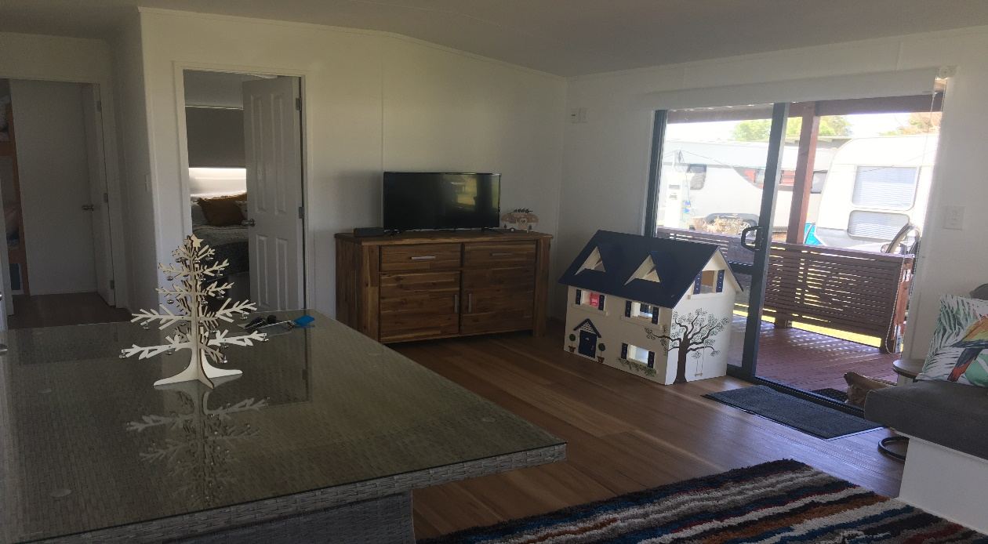

Things to do in Mangawhai
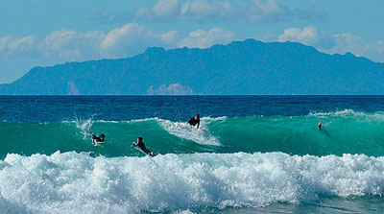

The best of both worlds
For surfers, the waves are consistent and for those looking for calmer water, the harbour and estuary offer safe swimming and paddling.

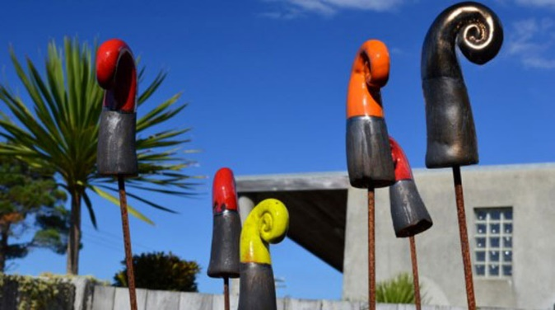

Rich with creativity
Artists of all kinds are prolific and if you take a drive around the area you will find an artist on every road.

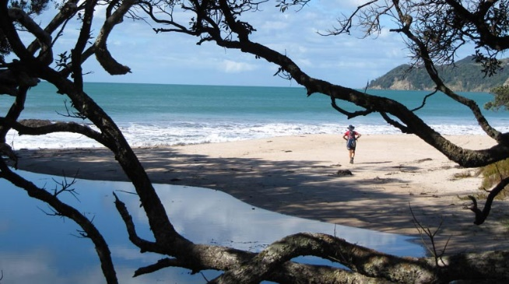

Coastal and bush walks
Stretch your legs on the Mangawhai coastal walk and don't miss the annual walking weekend, art trail and food and wine festival.

History and culture
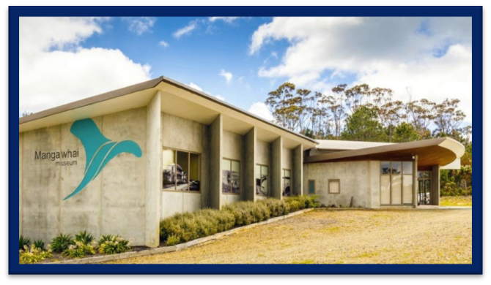
Your stay to Mangawhai isn't complete without a visit to our modern museum, for a fascinating trip through our past.
Eating out
There's little chance of gastro boredom, with a wide range of eateries from iconic kiwi to authentic French, casual takeaways to fine dining.

Deliciousness at every turn
Home to Bennetts Chocolates, wine labels Te Whai Bay, Millars and Lochiel plus olive oil producers Toru Waiwai, Divinity, EVO and Lola.

Local markets
Local artists, crafters, food producers and treasure trovers offer a substantial array of stalls at markets throughout the year.

A smorgasbord of activities
Play 18 holes of golf, go bowling, kayak or paddleboard the estuary, fish off the jetty, take the kids to the activity zone… you're spoilt for choice.

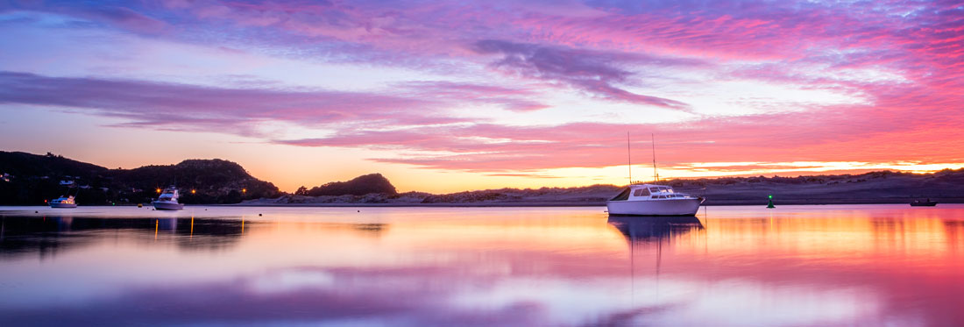
We hope to hear from you soon!

To enquire or make a booking please contact Amy – office@idfnz.org.nz or free phone
0508 300 600. Please do not contact the campsites directly as all bookings are made through the IDFNZ office.

