WELCOME TO
REDBEACH

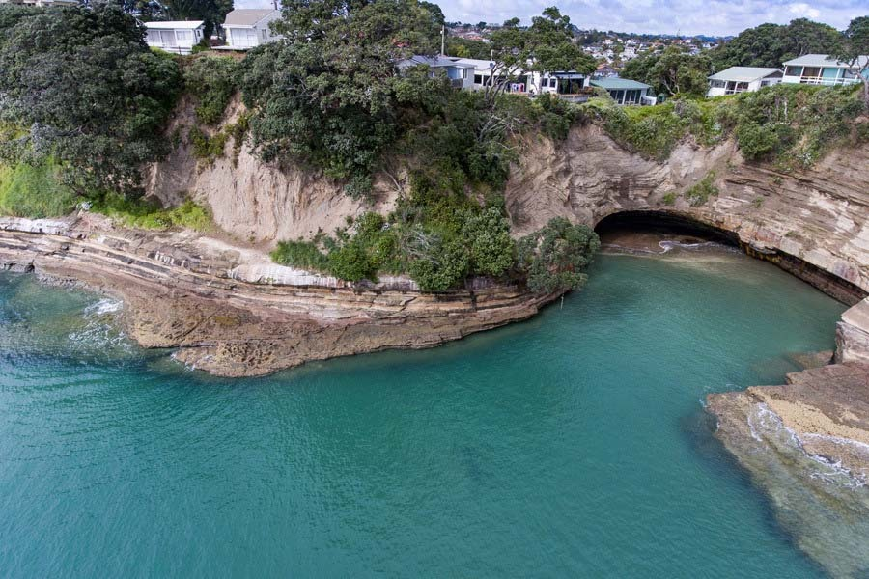
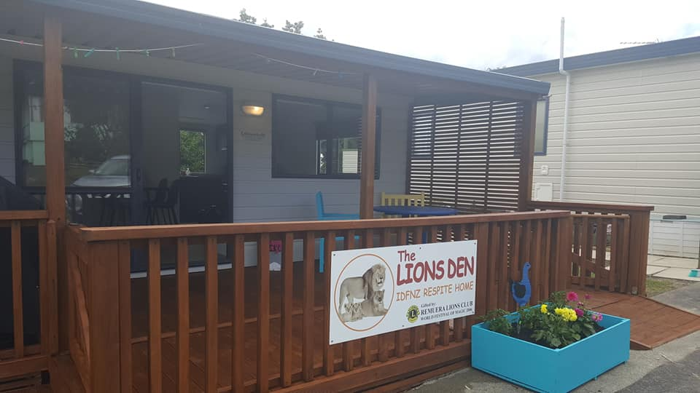
The Foundation is committed to offering respite care to patient members/families affected by the pressures of on-going health issues. Red Beach is on of the Respite homes available for use by our Patient members; this facility is very precious to us and we are grateful to all the trusts, businesses and individuals that have helped us to fundraise to establish and maintain this for our members.
Less than half an hour drive from Auckland City is our Red Beach Holiday home “The Lion’s Den” Situated in a quiet location 100mm from the campsites very own private beach, the “Lion’s Den” respite home is the place to go for much needed time out for both children and their families.
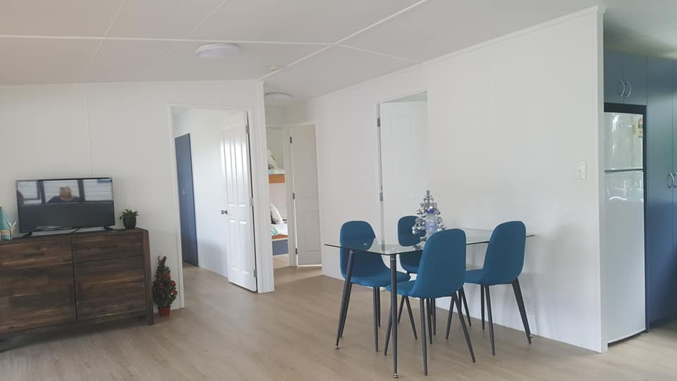
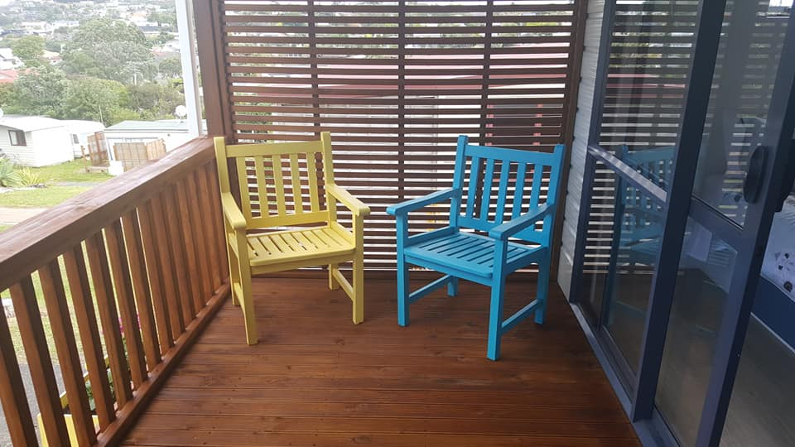
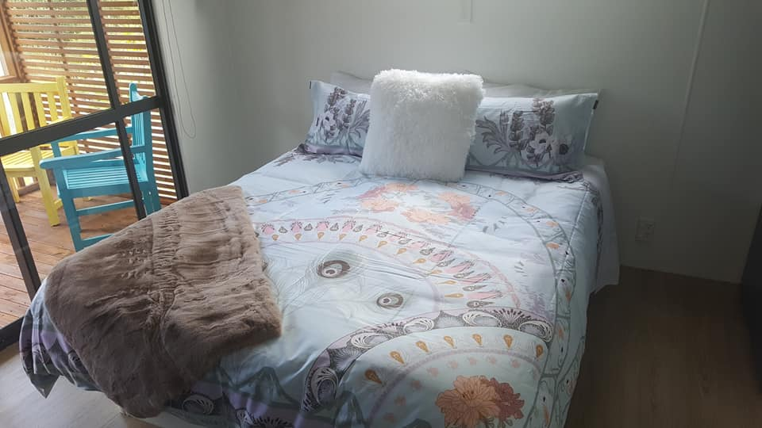
Our Red Beach house sleeps up to 6 People and is fully self-contained with everything a family needs all you need to bring is yourselves!

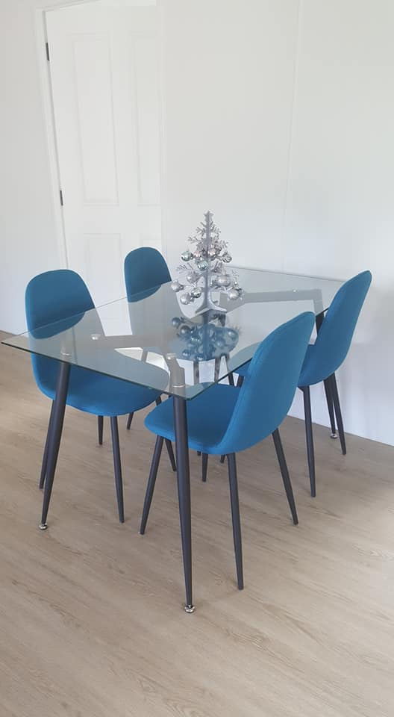
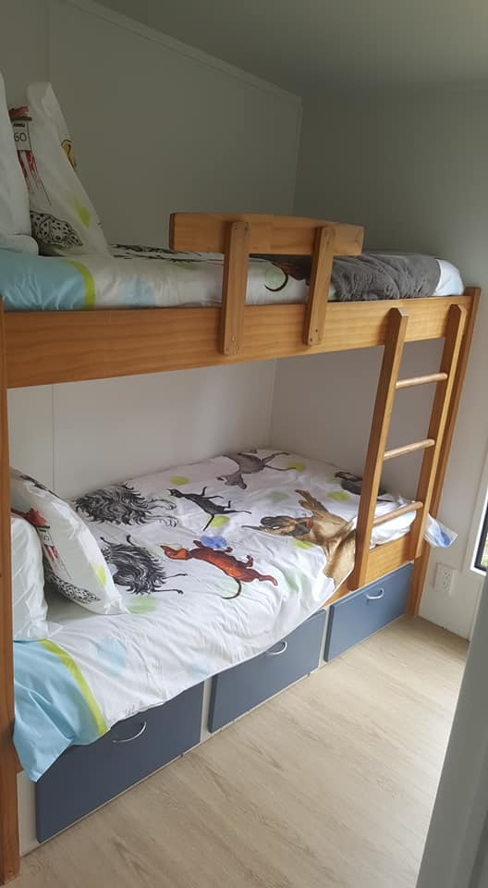
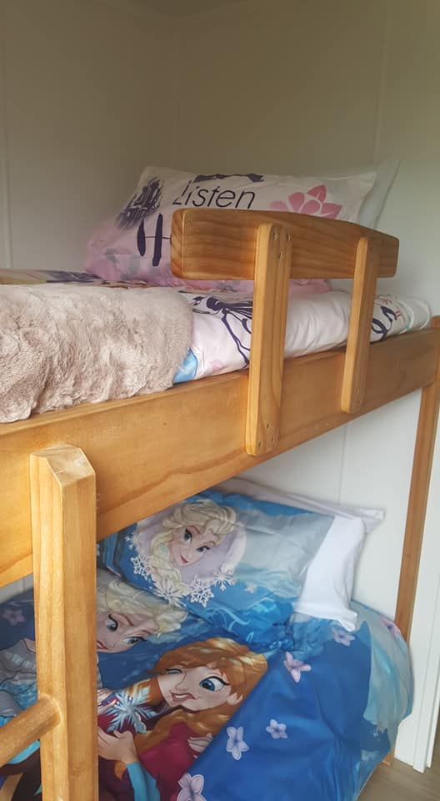
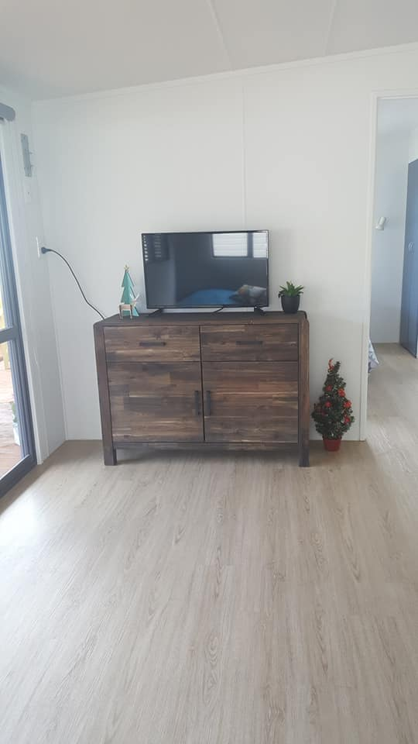
Booking your Holiday
We ask that you complete a booking Request form at least one month in advance of a planned holiday to allow time to process your request
The cost for hiring this fantastic home is as follows
$50 – Deposit (includes first night’s accommodation)
$20 – Per night (after initial $50 deposit has been paid)
Bookings can be made a maximum of 6 months in advance. One “Summer” holiday booking per family/per holiday home in peak summer periods (Dec-Mar) however there is no limit on off-peak/winter bookings. All homes are well insulated and suitable for winter use.
Terms and Conditions
All bookings are subject to availability
No Animals (Foundation policy regardless of campsite rules)
No Smoking
No Illegal substances
No Wilful damage of property
In the case of genuine medical treatment involving syringe use, we require further details in order to ensure satisfactory safety and disposal arrangements are in place.
Once your booking is accepted full payment is required a minimum of 2 weeks in advance of occupancy. A portion of the booking donation is non – refundable to cover admin expenses.
Where bookings are cancelled up to 2 weeks prior to the occupancy date, the payment may be deferred to an agreed alternative date falling within 6 months. Where bookings are cancelled less than the 2-week lead time or where a suitable booking is not agreed within the following 6 months a partial refund will be made, with the initial $50 booking fee being deducted to offset admin booking expenses.
The only thing we ask is that you use the vacuum cleaner stored in the main bedroom wardrobe and vacuum the floors, ensure the BBQ is clean and dishes are done before leaving. A $50 cleaning fee will be charged for failure to do so.

Things to do at Red Beach

Our holiday accommodation on the Hibiscus Coast is located 100m from a private beach. Our site is perfectly positioned between Red Beach and Orewa Beach on Auckland’s Hibiscus Coast.
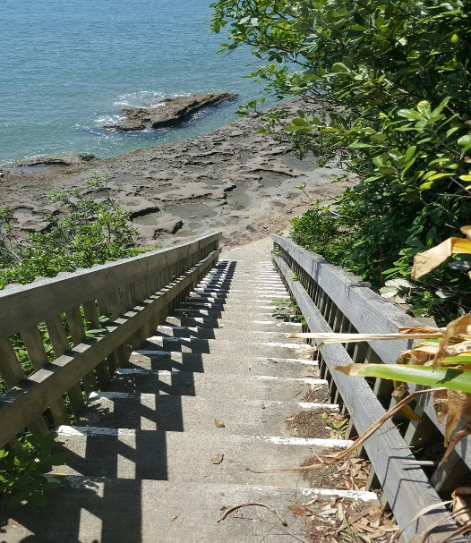
Jacob’s Ladder
Descend the cliff face via “Jacob's Ladder" to access Pinewoods Holiday Park’s private beach, only accessible by our guests. This beach is particularly suitable for family groups where many happy hours can be spent exploring rock pools, surf casting and making sand castles.

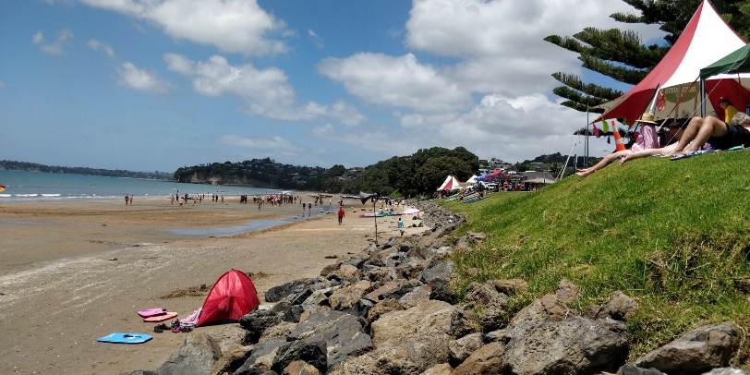

Red Beach
Red Beach is located between our site and Whangaparaoa. It is a popular beach for our guests because of easy, direct road access. The Surf Patrol Club operates during the summer and provides safe swimming. Each year the Surf Patrol Club hosts its annual International Surf Carnival.

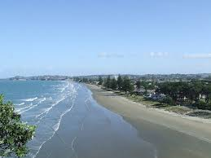
Orewa Beach
On the other side of the Red Beach estuary lies Orewa Beach, which offers 3km of glorious golden sand. This beach is safe for swimming and can also be used for kite surfing, windsurfing, surfing and kayaking. Above the beach, on a large grassed area, is a fabulous playground your children will love. And just across the road, you can enjoy great food at one of the many cafés and restaurants. To explore the area, you can walk or cycle along the Millennium Walkway.

Attractions Near By

Wenderholm Regional Park – At the mouth of the Puhoi River is Wenderholm. Take a picnic and enjoy the beautiful grounds and mainland coastal forest.
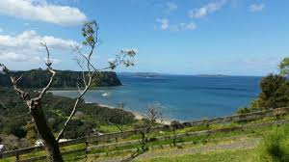

Waiwera Thermal Resort – Unwind and relax at Waiwera Thermal Resort, just 10 minutes’ drive from Pinewoods Holiday Park. These natural thermal pools are sheltered by native bush and provide the perfect surroundings for the whole family to enjoy.

Snowplanet – Snow lovers can ski, snowboard, tube or toboggan all year round at Snowplanet, only five minutes’ drive from us. You can rent clothes and equipment or bring your own.

West Coast beaches - visit the amazing beaches on the West Coast like Piha and the black sand beach at Muriwai.

Historic Puhoi - visit the historic Puhoi Pub and watch cheese being made at the Puhoi Valley Cheese Factory.
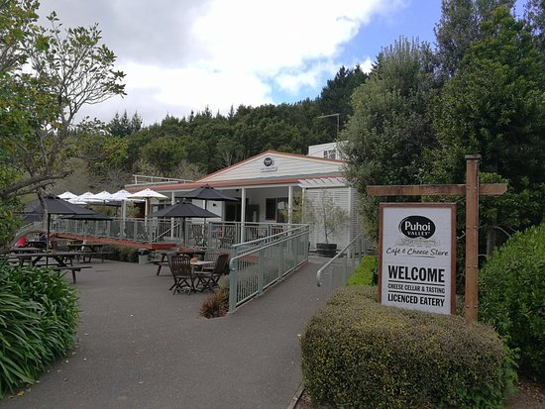

Warkworth - take a walk along the river or enjoy a trip on the historic schooner.

Golf - Enjoy a round at nearby Wainui, Whangaparaoa Golf Club or Omaha Beach Golf Club.

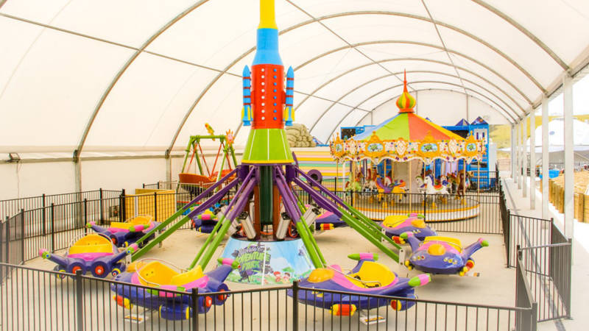
Silverdale Adventure Park – Try the Downhill Luge, Cosmic Playzone, 7D Cinema, Tube slide, the Big Slip waterslide, vertical bungy or dual Zipline! There is something for all ages here!

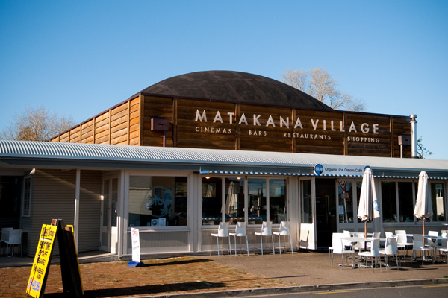

Matakana - there's lots on offer in Matakana from vineyards to restaurants, Omaha golf course and beaches.

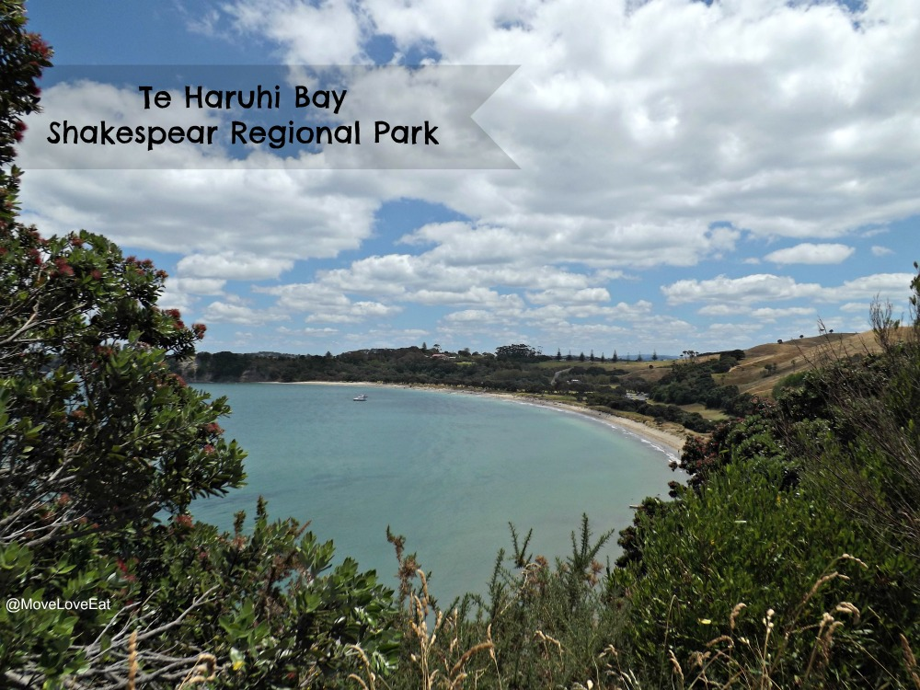
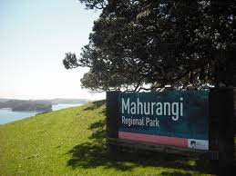
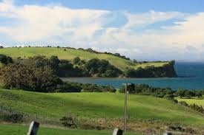
Regional Parks - Explore nearby Shakespear or Mahurangi.

We hope to hear from you soon!
To enquire or make a booking please contact Amy – office@idfnz.org.nz or free phone 0508 300 600. Please do not contact the campsites directly as all bookings are made through the IDFNZ office.
