WELCOME TO
CAIRNMUIR

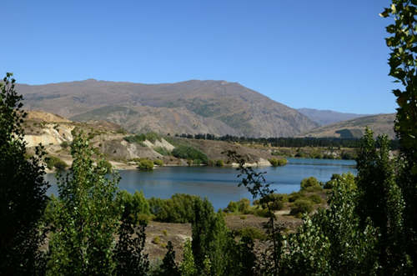
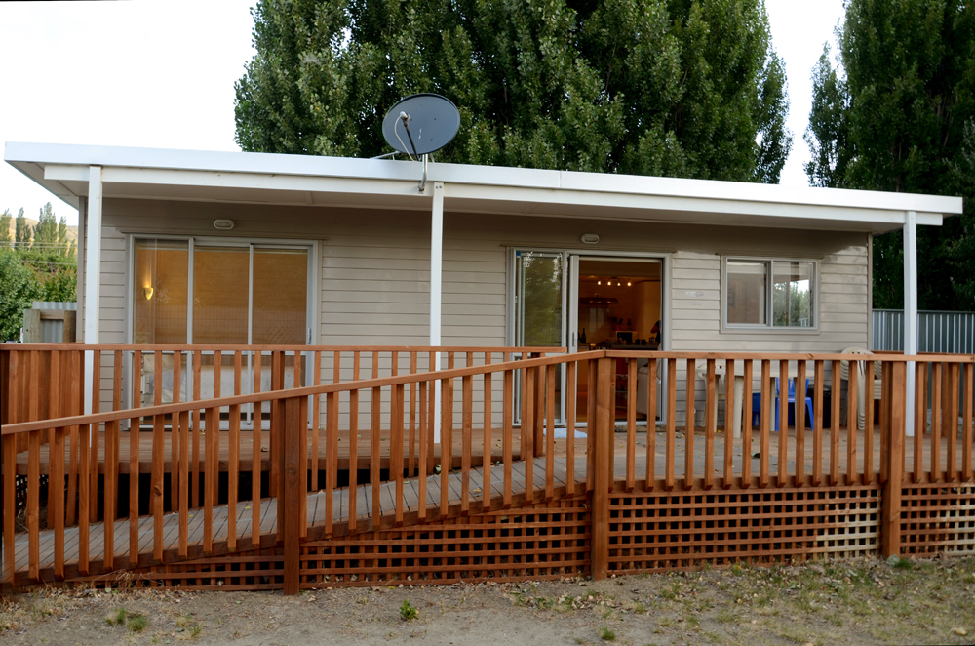

The Foundation is committed to offering respite care to patient members/families affected by the pressures of on-going health issues. Cairnmuir is one of the Respite homes available for use by our Patient members; this facility is very precious to us and we are grateful to all the trusts, businesses and individuals that have helped us to fundraise to establish and maintain this for our members.

The Cairnmuir respite home is the place to go for much needed time out for both children and their families.

Our Cairnmuir house sleeps up to 6 People and is fully self-contained with everything a family needs all you need to bring is yourselves!

Booking your Holiday
We ask that you complete a booking Request form at least one month in advance of a planned holiday to allow time to process your request
The cost for hiring this fantastic home is as follows
$50 – Deposit (includes first night’s accommodation)
$20 – Per night (after initial $50 deposit has been paid)
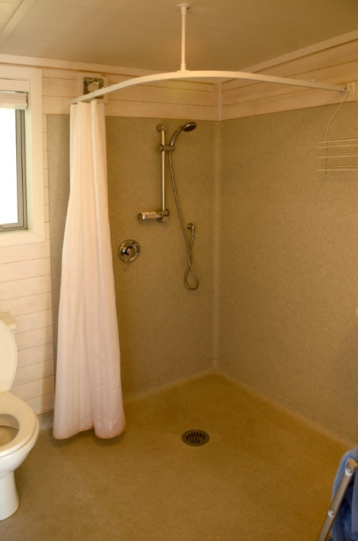
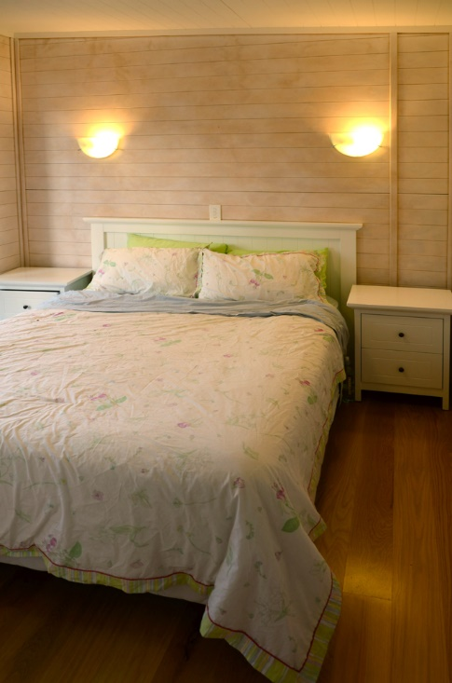
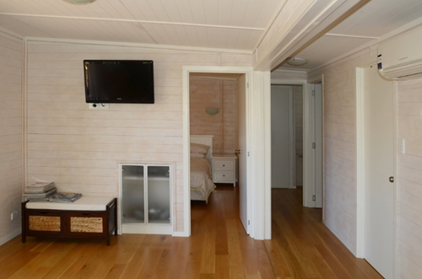
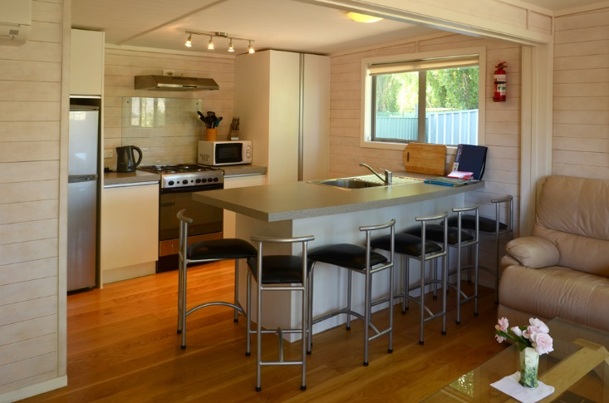
Bookings can be made a maximum of 6 months in advance. One “Summer” holiday booking per family/per holiday home in peak summer periods (Dec-Mar) however there is no limit on off-peak/winter bookings. All homes are well insulated and suitable for winter use.
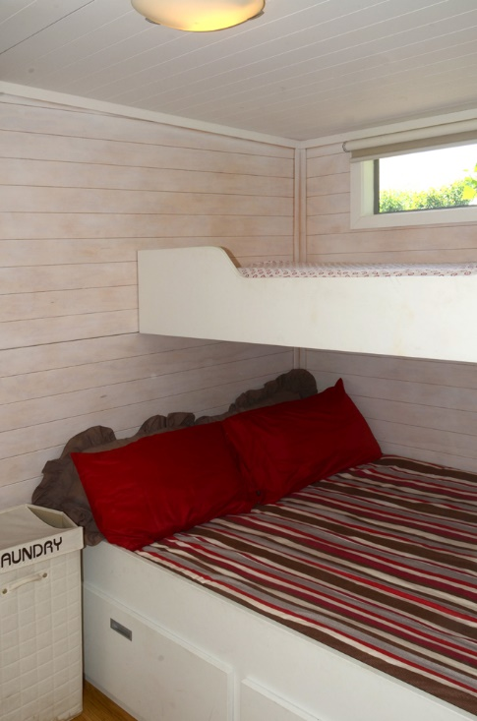

Terms and Conditions
All bookings are subject to availability
No Animals (Foundation policy regardless of campsite rules)
No Smoking
No Illegal substances
No Wilful damage of property
In the case of genuine medical treatment involving syringe use, we require further details in order to ensure satisfactory safety and disposal arrangements are in place.
Once your booking is accepted full payment is required a minimum of 2 weeks in advance of occupancy. A portion of the booking donation is non – refundable to cover admin expenses.
Where bookings are cancelled up to 2 weeks prior to the occupancy date, the payment may be deferred to an agreed alternative date falling within 6 months. Where bookings are cancelled less than the 2-week lead time or where a suitable booking is not agreed within the following 6 months a partial refund will be made, with the initial $50 booking fee being deducted to offset admin booking expenses.
The only thing we ask is that you use the vacuum cleaner stored in the main bedroom wardrobe and vacuum the floors, ensure the BBQ is clean and dishes are done before leaving. A $50 cleaning fee will be charged for failure to do so.

Central Otago plays host to many attractions in the area, these are as varied as your imagination.

Here are a few things to get you started.

​Skiing and Snowboarding in one of the many nearby ski fields.
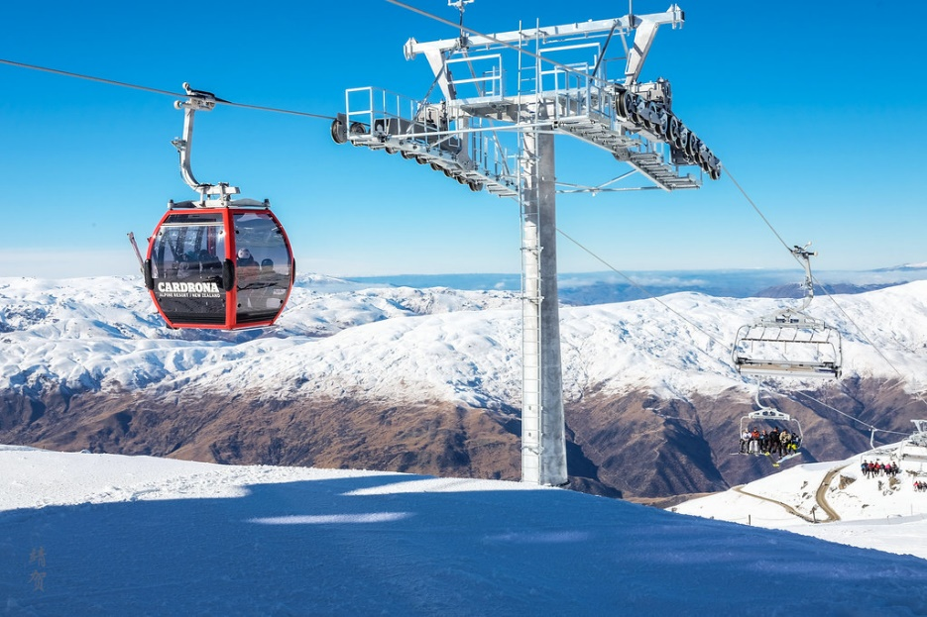

Motorsport Highlands Motorsport park is 10 minutes away
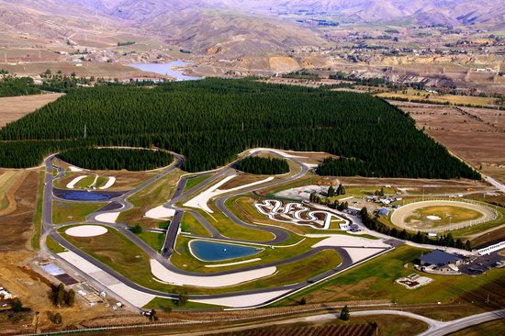

Chinese mining, the Gold Rush, The Clyde Dam, Museums, The Bannockburn Sluicings.
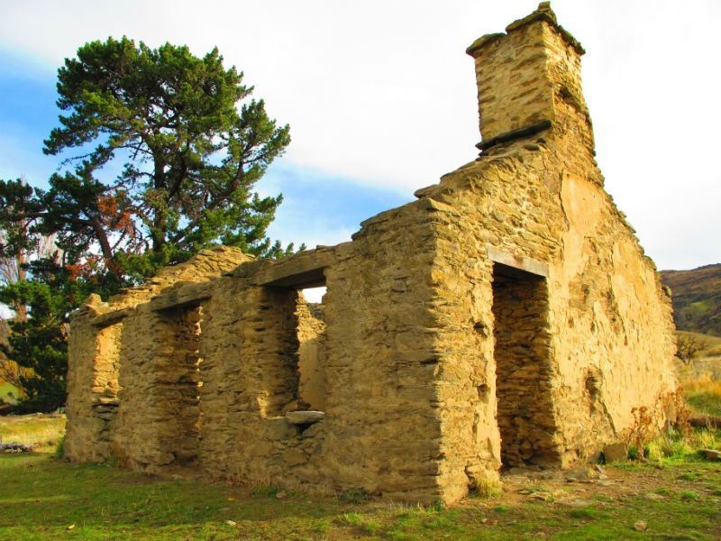

Lake Dunstan and The Bannockburn Inlet Renown for swimming, boating and Jet Skiing.

We hope to hear from you soon!

To enquire or make a booking please contact Amy – office@idfnz.org.nz or free phone
0508 300 600. Please do not contact the campsites directly as all bookings are made through the IDFNZ office.

